Flexbox

Table of Contents
Flexbox Layout 3
CSS Flexbox Background 3
Flexbox basics and terminology 3
Properties for the Parent (flex container) 4
display 4
flex-direction 5
flex-wrap 6
flex-flow 6
justify-content 7
align-items 9
align-content 10
gap, row-gap, column-gap 12
Properties for the Children (flex items) 13
order 13
flex-grow 13
flex-shrink 14
flex-basis 14
flex 14
align-self 15
Prefixing Flexbox 15
CSS Flexbox Examples 16
Example1 18
Example2 20
Cheatsheet 22
flex container attributes 22
flex items attributes 23
More reading resources 24
Flexbox and absolute positioning 24
Adaptive Photo layout 24
Using Flexbox and text ellipsis together 24
Designing A Product Page Layout with Flexbox 24
Balancing on a Pivot with Flexbox 24
Useful Flexbox Technique: Alignment Shifting Wrapping 24
Flexbox and Truncated Text 24
Filling the Space in the Last Row with Flexbox 24

Flexbox Layout

Chris Coyier on Apr 8, 2013
This complete guide explains everything about flexbox, focusing on all the different possible properties for the parent element (the flex container) and the child elements (the flex items). It also includes history, demos, patterns, and a browser support chart.

CSS Flexbox Background
The Flexbox Layout (Flexible Box) module provides a more efficient way to lay out, align and distribute space among items in a container, even when their size is unknown and/or dynamic (thus the word “flex”).
The main idea behind the flex layout is to give the container the ability to alter its items’ width/height (and order) to best fill the available space (mostly to accommodate to all kind of display devices and screen sizes). A flex container expands items to fill available free space or shrinks them to prevent overflow.
Most importantly, the flexbox layout is direction-agnostic as opposed to the regular layouts (block which is vertically-based and inline which is horizontally-based). While those work well for pages, they lack flexibility (no pun intended) to support large or complex applications (especially when it comes to orientation changing, resizing, stretching, shrinking, etc.).
Note: Flexbox layout is most appropriate to the components of an application, and small-scale layouts, while the CSS Grid layout is intended for larger scale layouts.

Flexbox basics and terminology
Since flexbox is a whole module and not a single property, it involves a lot of things including its whole set of properties. Some of them are meant to be set on the container (parent element, known as “flex container”) whereas the others are meant to be set on the children (said “flex items”).
If “regular” layout is based on both block and inline flow directions, the flex layout is based on “flex-flow directions”. Please have a look at this figure from the specification, explaining the main idea behind the flex layout.
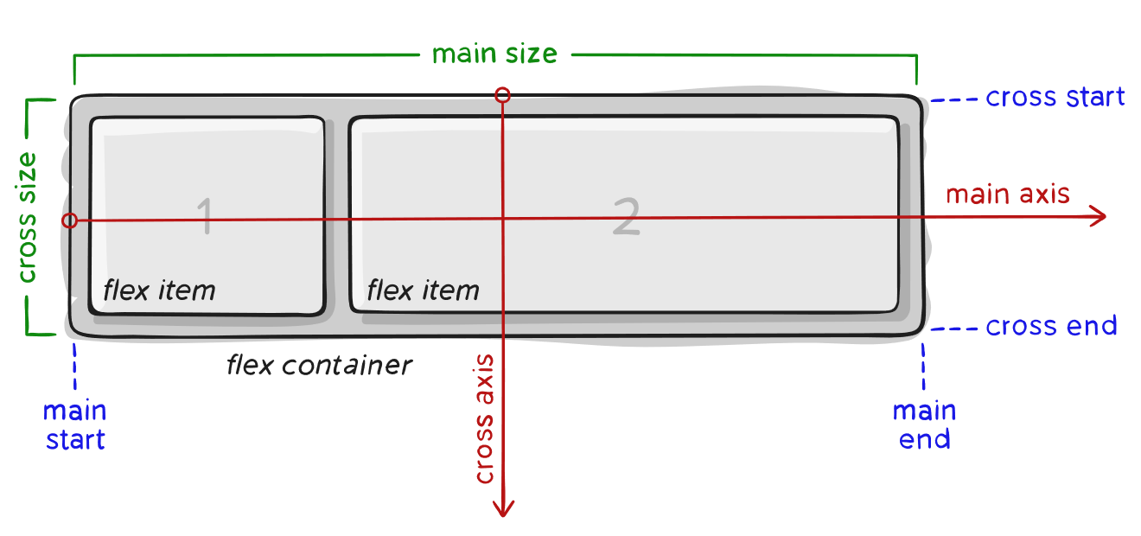
Items will be laid out following either the main axis (from main-start to main-end) or the cross axis (from cross-start to cross-end).
- main axis – The main axis of a flex container is the primary axis along which flex items are laid out. Beware, it is not necessarily horizontal; it depends on the flex-direction property (see below).
- main-start | main-end – The flex items are placed within the container starting from main-start and going to main-end.
- main size – A flex item’s width or height, whichever is in the main dimension, is the item’s main size. The flex item’s main size property is either the ‘width’ or ‘height’ property, whichever is in the main dimension.
- cross axis – The axis perpendicular to the main axis is called the cross axis. Its direction depends on the main axis direction.
- cross-start | cross-end – Flex lines are filled with items and placed into the container starting on the cross-start side of the flex container and going toward the cross-end side.
- cross size – The width or height of a flex item, whichever is in the cross dimension, is the item’s cross size. The cross size property is whichever of ‘width’ or ‘height’ that is in the cross dimension.

Properties for the Parent (flex container)

display
This defines a flex container; inline or block depending on the given value. It enables a flex context for all its direct children.
.container {
display: flex; /* or inline-flex */
}
Note that CSS columns have no effect on a flex container.

flex-direction
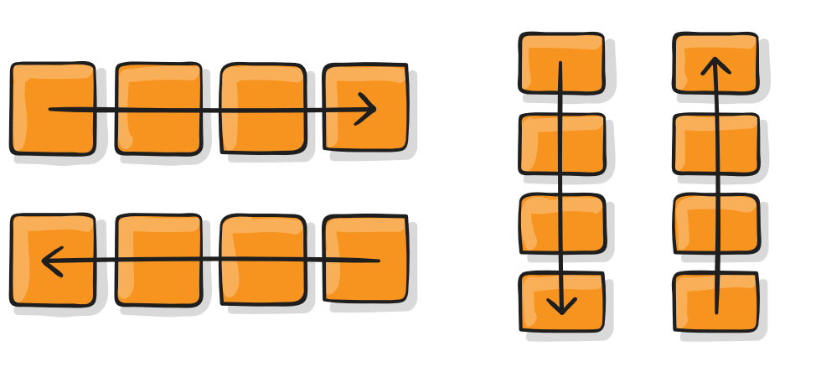
This establishes the main-axis, thus defining the direction flex items are placed in the flex container. Flexbox is (aside from optional wrapping) a single-direction layout concept. Think of flex items as primarily laying out either in horizontal rows or vertical columns.
.container {
flex-direction: row | row-reverse | column | column-reverse;
}
- row (default): left to right in ltr; right to left in rtl
- row-reverse: right to left in ltr; left to right in rtl
- column: same as row but top to bottom
- column-reverse: same as row-reverse but bottom to top

flex-wrap
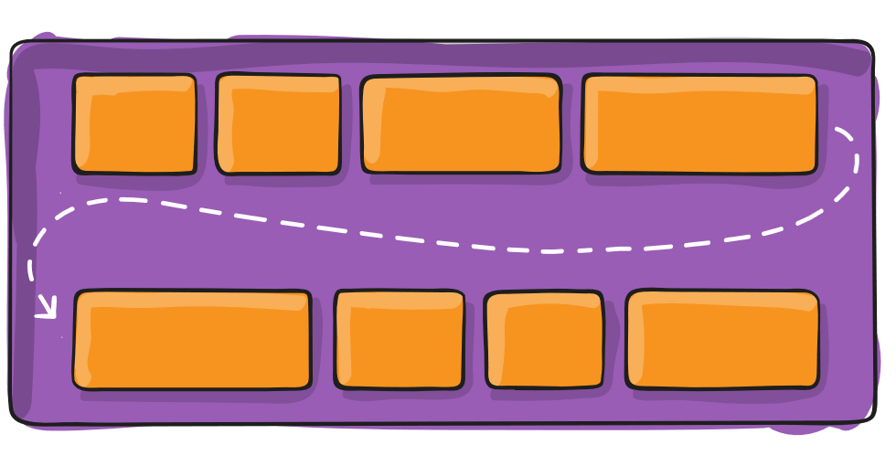
By default, flex items will all try to fit onto one line. You can change that and allow the items to wrap as needed with this property.
.container {
flex-wrap: nowrap | wrap | wrap-reverse;
}
- nowrap (default): all flex items will be on one line
- wrap: flex items will wrap onto multiple lines, from top to bottom.
- wrap-reverse: flex items will wrap onto multiple lines from bottom to top.
There are some visual demos of flex-wrap here.

flex-flow
This is a shorthand for the flex-direction and flex-wrap properties, which together define the flex container’s main and cross axes. The default value is row nowrap.
.container {
flex-flow: column wrap;
}

justify-content
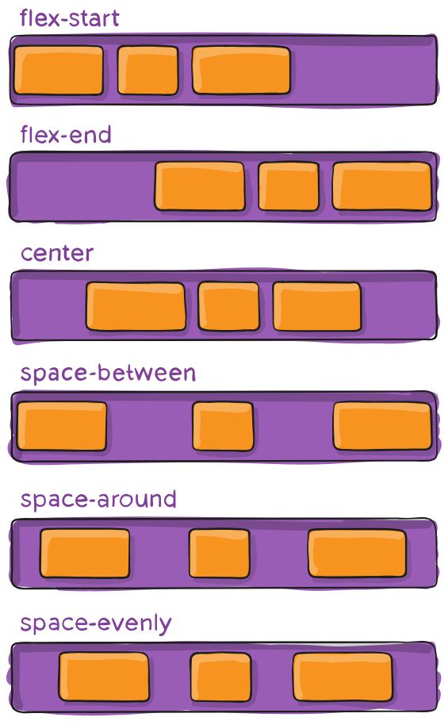
This defines the alignment along the main axis. It helps distribute extra free space leftover when either all the flex items on a line are inflexible, or are flexible but have reached their maximum size. It also exerts some control over the alignment of items when they overflow the line.
.container {
justify-content: flex-start | flex-end | center | space-between | space-around | space-evenly | start | end | left | right ... + safe | unsafe;
}
- flex-start (default): items are packed toward the start of the flex-direction.
- flex-end: items are packed toward the end of the flex-direction.
- start: items are packed toward the start of the writing-mode direction.
- end: items are packed toward the end of the writing-mode direction.
- left: items are packed toward left edge of the container, unless that doesn’t make sense with the flex-direction, then it behaves like start.
- right: items are packed toward right edge of the container, unless that doesn’t make sense with the flex-direction, then it behaves like end.
- center: items are centered along the line
- space-between: items are evenly distributed in the line; first item is on the start line, last item on the end line
- space-around: items are evenly distributed in the line with equal space around them. Note that visually the spaces aren’t equal, since all the items have equal space on both sides. The first item will have one unit of space against the container edge, but two units of space between the next item because that next item has its own spacing that applies.
- space-evenly: items are distributed so that the spacing between any two items (and the space to the edges) is equal.
Note that that browser support for these values is nuanced. For example, space-between never got support from some versions of Edge, and start/end/left/right aren’t in Chrome yet. MDN has detailed charts. The safest values are flex-start, flex-end, and center.
There are also two additional keywords you can pair with these values: safe and unsafe. Using safe ensures that however you do this type of positioning, you can’t push an element such that it renders off-screen (e.g. off the top) in such a way the content can’t be scrolled too (called “data loss”).

align-items
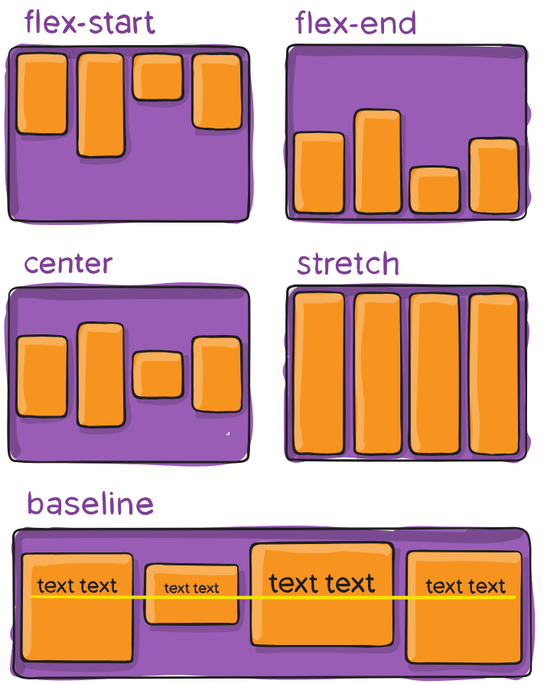
This defines the default behavior for how flex items are laid out along the cross axis on the current line. Think of it as the justify-content version for the cross-axis (perpendicular to the main-axis).
.container {
align-items: stretch | flex-start | flex-end | center | baseline | first baseline | last baseline | start | end | self-start | self-end + ... safe | unsafe;
}
- stretch (default): stretch to fill the container (still respect min-width/max-width)
- flex-start / start / self-start: items are placed at the start of the cross axis. The difference between these is subtle, and is about respecting the flex-direction rules or the writing-mode rules.
- flex-end / end / self-end: items are placed at the end of the cross axis. The difference again is subtle and is about respecting flex-direction rules vs. writing-mode rules.
- center: items are centered in the cross-axis
- baseline: items are aligned such as their baselines align
The safe and unsafe modifier keywords can be used in conjunction with all the rest of these keywords (although note browser support), and deal with helping you prevent aligning elements such that the content becomes inaccessible.

align-content
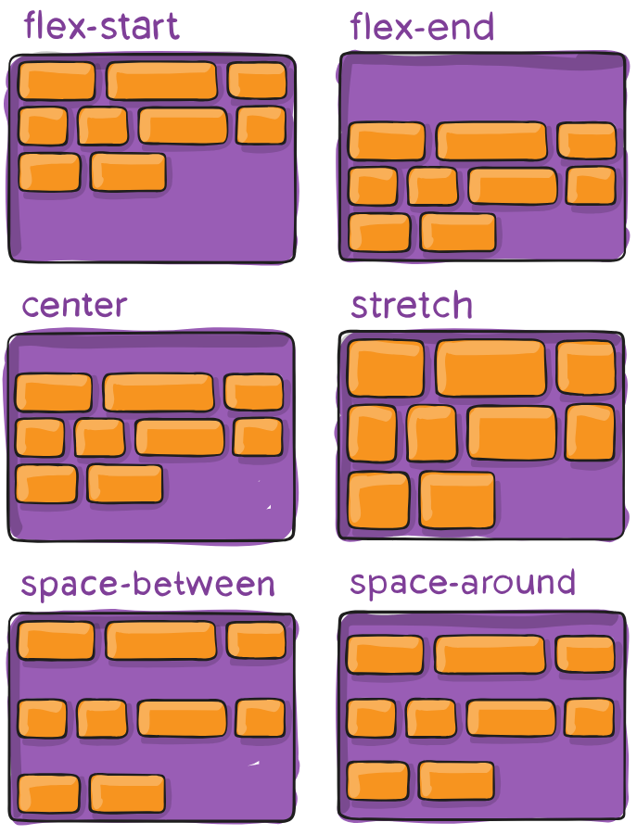
This aligns a flex container’s lines within when there is extra space in the cross-axis, similar to how justify-content aligns individual items within the main-axis.
Note: This property only takes effect on multi-line flexible containers, where flex-wrap is set to either wrap or wrap-reverse). A single-line flexible container (i.e. where flex-wrap is set to its default value, no-wrap) will not reflect align-content.
.container {
align-content: flex-start | flex-end | center | space-between | space-around | space-evenly | stretch | start | end | baseline | first baseline | last baseline + ... safe | unsafe;
}
- normal (default): items are packed in their default position as if no value was set.
- flex-start / start: items packed to the start of the container. The (more supported) flex-start honors the flex-direction while start honors the writing-mode direction.
- flex-end / end: items packed to the end of the container. The (more support) flex-end honors the flex-direction while end honors the writing-mode direction.
- center: items centered in the container
- space-between: items evenly distributed; the first line is at the start of the container while the last one is at the end
- space-around: items evenly distributed with equal space around each line
- space-evenly: items are evenly distributed with equal space around them
- stretch: lines stretch to take up the remaining space
The safe and unsafe modifier keywords can be used in conjunction with all the rest of these keywords (although note browser support), and deal with helping you prevent aligning elements such that the content becomes inaccessible.

gap, row-gap, column-gap
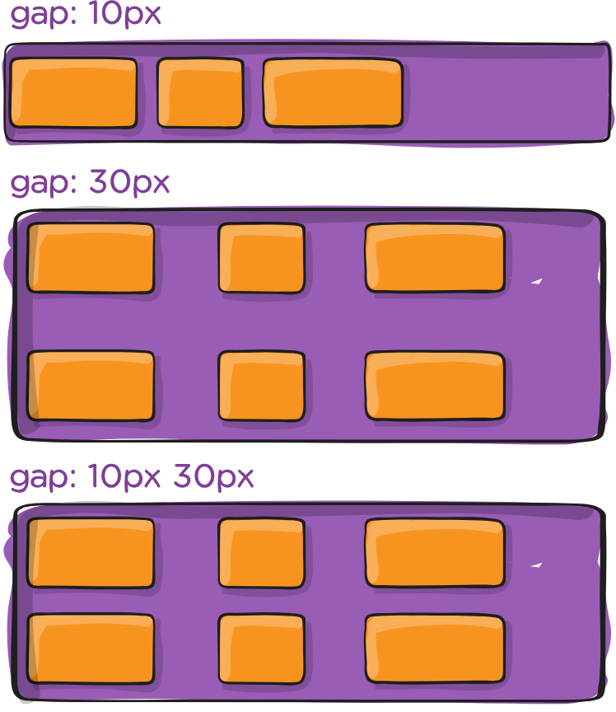
The gap property explicitly controls the space between flex items. It applies that spacing only between items not on the outer edges.
.container {
display: flex;
...
gap: 10px;
gap: 10px 20px; /* row-gap column gap */
row-gap: 10px;
column-gap: 20px;
}
The behavior could be thought of as a minimum gutter, as if the gutter is bigger somehow (because of something like justify-content: space-between;) then the gap will only take effect if that space would end up smaller.
It is not exclusively for flexbox, gap works in grid and multi-column layout as well.

Properties for the Children (flex items)

order
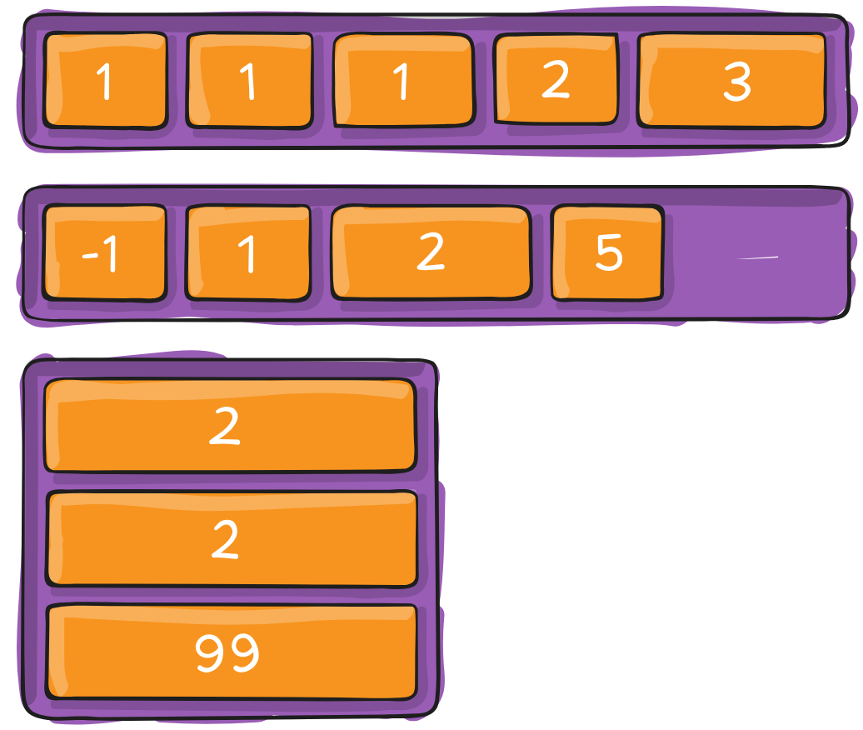
By default, flex items are laid out in the source order. However, the order property controls the order in which they appear in the flex container.
.item {
order: 5; /* default is 0 */
}
Items with the same order revert to source order.

flex-grow
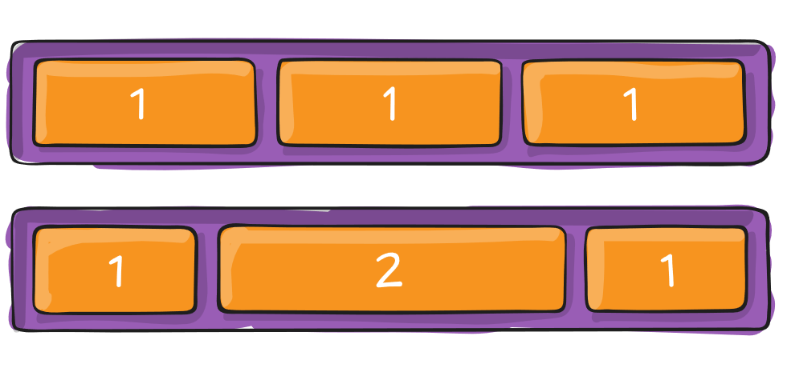
This defines the ability for a flex item to grow if necessary. It accepts a unitless value that serves as a proportion. It dictates what amount of the available space inside the flex container the item should take up.
If all items have flex-grow set to 1, the remaining space in the container will be distributed equally to all children. If one of the children has a value of 2, that child would take up twice as much of the space as either one of the others (or it will try, at least).
.item {
flex-grow: 4; /* default 0 */
}
Negative numbers are invalid.

flex-shrink
This defines the ability for a flex item to shrink if necessary.
.item {
flex-shrink: 3; /* default 1 */
}
Negative numbers are invalid.

flex-basis
This defines the default size of an element before the remaining space is distributed. It can be a length (e.g. 20%, 5rem, etc.) or a keyword. The auto keyword means “look at my width or height property” (which was temporarily done by the main-size keyword until deprecated). The content keyword means “size it based on the item’s content” – this keyword isn’t well supported yet, so it’s hard to test and harder to know what its brethren max-content, min-content, and fit-content do.
.item {
flex-basis: | auto; /* default auto */
}
If set to 0, the extra space around content isn’t factored in. If set to auto, the extra space is distributed based on its flex-grow value. See this graphic.

flex
This is the shorthand for flex-grow, flex-shrink and flex-basis combined. The second and third parameters (flex-shrink and flex-basis) are optional. The default is 0 1 auto, but if you set it with a single number value, like flex: 5;, that changes the flex-basis to 0%, so it’s like setting flex-grow: 5; flex-shrink: 1; flex-basis: 0%;.
.item {
flex: none | [ <'flex-grow'> <'flex-shrink'>? || <'flex-basis'> ]
}
It is recommended that you use this shorthand property rather than set the individual properties. The shorthand sets the other values intelligently.

align-self
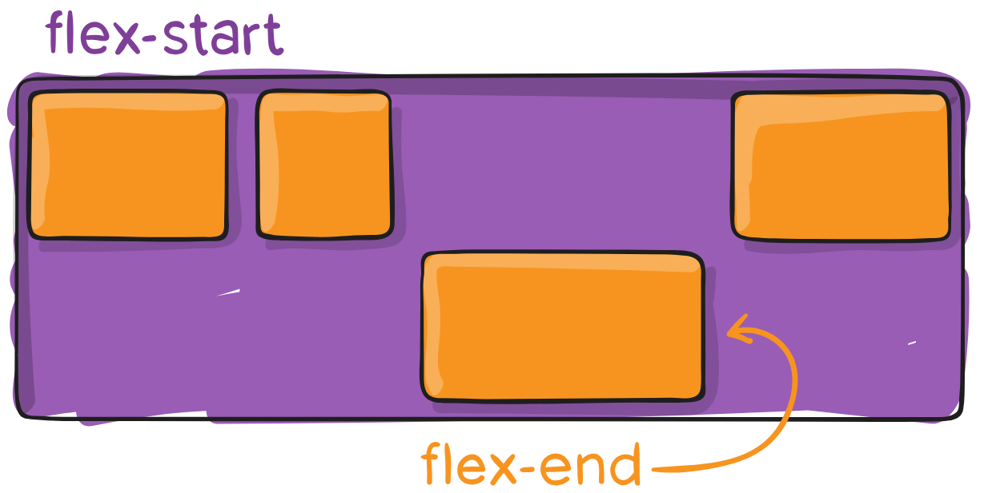
This allows the default alignment (or the one specified by align-items) to be overridden for individual flex items.
Please see the align-items explanation to understand the available values.
.item {
align-self: auto | flex-start | flex-end | center | baseline | stretch;
}
Note that float, clear and vertical-align have no effect on a flex item.

Prefixing Flexbox
CSS Flexbox is widely supported in all modern browsers, but requires some vendor prefixing to support the legacy browsers, like Internet Explorer (which has been discontinued for a while now). It doesn’t just include prepending properties with the vendor prefix, but there are actually entirely different property and value names. This is because the Flexbox spec has changed over time, creating an “old”, “tweener”, and “new” versions.
Perhaps the best way to handle this is to write in the new (and final) syntax and run your CSS through Autoprefixer, which handles the fallbacks very well.
Alternatively, here’s a Sass @mixin to help with some of the prefixing, which also gives you an idea of what kind of things need to be done:
@mixin flexbox() {
display: -webkit-box;
display: -moz-box;
display: -ms-flexbox;
display: -webkit-flex;
display: flex;
}
@mixin flex($values) {
-webkit-box-flex: $values;
-moz-box-flex: $values;
-webkit-flex: $values;
-ms-flex: $values;
flex: $values;
}
@mixin order($val) {
-webkit-box-ordinal-group: $val;
-moz-box-ordinal-group: $val;
-ms-flex-order: $val;
-webkit-order: $val;
order: $val;
}
.wrapper {
@include flexbox();
}
.item {
@include flex(1 200px);
@include order(2);
}

CSS Flexbox Examples
Let’s start with a very very simple example, solving an almost daily problem: perfect centering. It couldn’t be any simpler if you use CSS Flexbox.
.parent {
display: flex;
height: 300px; /* Or whatever */
}
.child {
width: 100px; /* Or whatever */
height: 100px; /* Or whatever */
margin: auto; /* Magic! */
}
This relies on the fact a margin set to auto in a flex container absorb extra space. So setting a margin of auto will make the item perfectly centered in both axes.
Now let’s use some more properties. Consider a list of 6 items, all with fixed dimensions, but can be auto-sized. We want them to be evenly distributed on the horizontal axis so that when we resize the browser, everything scales nicely, and without media queries.
<html>
<head>
<title>My Page</title>
<link rel="stylesheet" href="UI.css">
</head>
<body>
<ul>
<li>I am list 0</li>
<li>I am list 1</li>
<li>I am list 2</li>
<li>I am list 3</li>
<li>I am list 4</li>
<!-- <li>I am list 5</li>
<li>I am list 7</li>
<li>I am list 8</li>
<li>I am list 9</li> -->
</ul>
</body>
</html>

ul {
display: flex; /* We first create a flex layout context */
/* Then we define the flow direction & if we allow the items to wrap
* Remember this is the same as:
* flex-direction: row;
* flex-wrap: wrap;
*/
flex-flow: row nowrap;
list-style: none; /* kill the bullets */
padding: 0; /* kill the default indent */
margin: 0;
background-color: blueviolet;
align-items: baseline;
height: 60%;
}
li{
border: 1px solid white;
padding: 5px;
margin:2px;
background-color: aquamarine;
border-radius: 2px;
}

Result
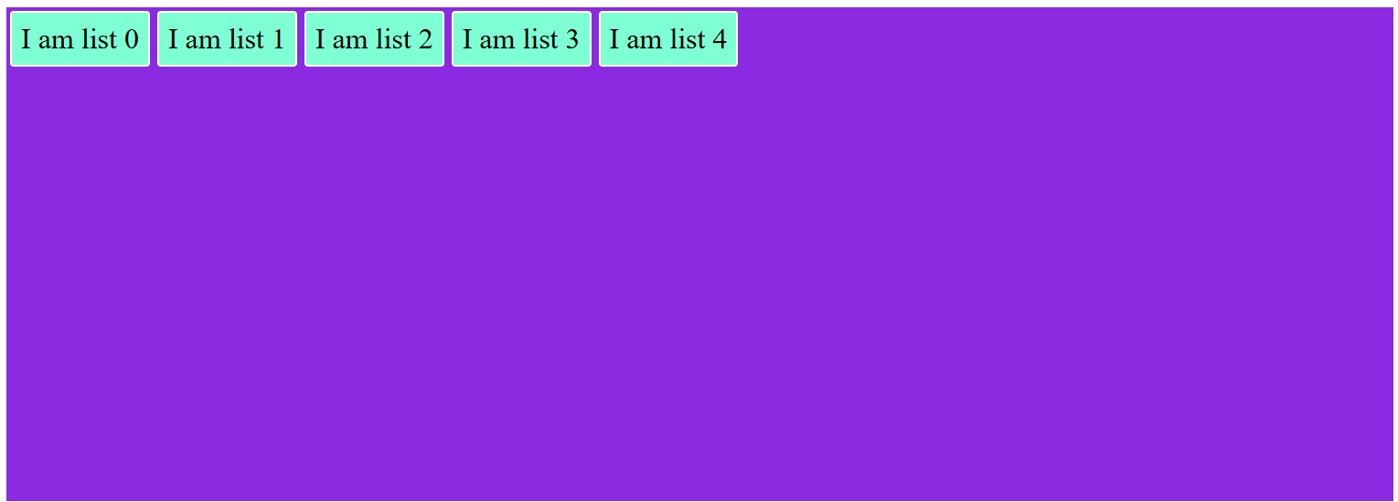

Example1
Let’s try something else. Imagine we have a right-aligned navigation element on the very top of our website, but we want it to be centered on medium-sized screens and single-columned on small devices. Easy enough.
/* Large */
.navigation {
display: flex;
flex-flow: row wrap;
/* This aligns items to the end line on main-axis */
justify-content: flex-end;
}
/* Medium screens */
@media all and (max-width: 800px) {
.navigation {
/* When on medium sized screens, we center it by evenly distributing empty space around items */
justify-content: space-around;
}
}
/* Small screens */
@media all and (max-width: 500px) {
.navigation {
/* On small screens, we are no longer using row direction but column */
flex-direction: column;
}
}
Code:
<html>
<head>
<title>My Page</title>
<link rel="stylesheet" href="UI.css">
</head>
<body>
<ul>
<ul class="navigation">
<li><a href="#">Home</a></li>
<li><a href="#">About</a></li>
<li><a href="#">Products</a></li>
<li><a href="#">Contact</a></li>
</ul>
</ul>
</body>
</html>

.navigation {
display: flex;
flex-flow: row wrap;
justify-content: flex-end;
list-style: none;
margin: 0;
background: deepskyblue;
}
.navigation a {
text-decoration: none;
display: block;
padding: 1em;
color: white;
}
.navigation a:hover {
background: #1565C0;
}
@media all and (max-width: 800px) {
.navigation {
justify-content: space-around;
}
}
@media all and (max-width: 600px) {
.navigation {
flex-flow: column wrap;
padding: 0;
}
.navigation a {
text-align: center;
padding: 10px;
border-top: 1px solid rgba(255, 255, 255,0.3);
border-bottom: 1px solid rgba(0, 0, 0, 0.1);
}
.navigation li:last-of-type a {
border-bottom: none;
}
}
Result:


Example2
Let’s try something even better by playing with flex items flexibility! What about a mobile-first 3-columns layout with full-width header and footer. And independent from source order.
.wrapper {
display: flex;
flex-flow: row wrap;
}
/* We tell all items to be 100% width, via flex-basis */
.wrapper > * {
flex: 1 100%;
}
/* We rely on source order for mobile-first approach
* in this case:
* 1. header
* 2. article
* 3. aside 1
* 4. aside 2
* 5. footer
*/
/* Medium screens */
@media all and (min-width: 600px) {
/* We tell both sidebars to share a row */
.aside { flex: 1 auto; }
}
/* Large screens */
@media all and (min-width: 800px) {
/* We invert order of first sidebar and main
* And tell the main element to take twice as much width as the other two sidebars
*/
.main { flex: 3 0px; }
.aside-1 { order: 1; }
.main { order: 2; }
.aside-2 { order: 3; }
.footer { order: 4; }
}
Code
<html>
<head>
<title>My Page</title>
<link rel="stylesheet" href="UI.css">
</head>
<body>
<div class="wrapper">
<header class="header">Header</header>
<article class="main">
<p>Pellentesque habitant morbi tristique senectus et netus et malesuada fames ac turpis egestas. Vestibulum tortor quam, feugiat vitae, ultricies eget, tempor sit amet, ante. Donec eu libero sit amet quam egestas semper. Aenean ultricies mi vitae est. Mauris placerat eleifend leo.</p>
</article>
<aside class="aside aside-1">Aside 1</aside>
<aside class="aside aside-2">Aside 2</aside>
<footer class="footer">Footer</footer>
</div>
</body>
</html>

.wrapper {
display: flex;
flex-flow: row wrap;
font-weight: bold;
text-align: center;
}
.wrapper > * {
padding: 10px;
flex: 1 100%;
}
.header {
background: tomato;
}
.footer {
background: lightgreen;
}
.main {
text-align: left;
background: deepskyblue;
}
.aside-1 {
background: gold;
}
.aside-2 {
background: hotpink;
}
@media all and (min-width: 600px) {
.aside { flex: 1 0 0; }
}
@media all and (min-width: 800px) {
.main { flex: 3 0px; }
.aside-1 { order: 1; }
.main { order: 2; }
.aside-2 { order: 3; }
.footer { order: 4; }
}
body {
padding: 2em;
}
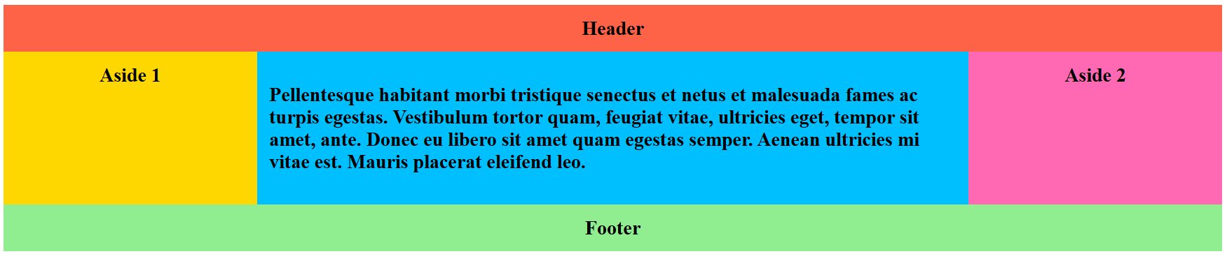

Cheatsheet

flex container attributes
.container {
/* Defines a flex container */
display: flex; /* or inline-flex */
/* Establishes direction aka main-axis flex items are placed in the flex container
row (default): left to right */
flex-direction: row | row-reverse | column | column-reverse;
/* By default, flex items will all try to fit onto one line (nowrap). */
flex-wrap: nowrap | wrap | wrap-reverse;
/* shorthand for the flex-direction and flex-wrap properties, which together define the flex container’s main and cross axes */
flex-flow: column wrap;
/* Defines the alignment along the main axis.
flex-start (default): items are packed toward the start of the flex-direction. */
justify-content: flex-start | flex-end | center | space-between | space-around |
space-evenly | start | end | left | right + ... | safe | unsafe;
/* This defines the default behavior for how flex items are laid out along the cross
axis on the current line. Think of it as the justify-content version for the cross-axis (perpendicular to the main-axis).
stretch (default): stretch to fill the container (still respect min-width/max-width) */
align-items: stretch | flex-start | flex-end | center | baseline | first baseline |
last baseline | start | end | self-start | self-end + ... | safe | unsafe;
/* Aligns a flex container’s lines within when there is extra space in the cross-axis,
similar to how justify-content aligns individual items within the main-axis.
normal (default): items are packed in their default position as if no value was set.
Note: This property only takes effect on multi-line flexible containers, where flex-wrap is set to either wrap or wrap-reverse ). A single-line flexible container (i.e. where flex-wrap is set to its default value, no-wrap ) will not reflect align-content .*/
align-content: flex-start | flex-end | center | space-between | space-around | space-evenly
| stretch | start | end | baseline | first baseline | last baseline + ... safe | unsafe;
/* gap property explicitly controls the space between flex items. It applies that spacing only between items not on the outer edges. */
gap: 10px;
gap: 10px 20px; /* row-gap column gap */
row-gap: 10px;
column-gap: 20px;
}

flex items attributes
.item{
/*Controls the order in which items appear in the flex container.*/
order: 5; /* default is 0 */
/* defines the ability for a flex item to grow if necessary. If all items have flex-grow set to 1 , the remaining space in the container will be distributed equally to all children. If one of the children has a value of 2 , that child would take up twice as much of the space as either one of the others (or it will try, at least). */
flex-grow: 4; /* Default is 0*/
/* Defines the ability for a flex item to shrink if necessary Negative numbers are invalid. */
flex-shrink: 3; /* default 1 */
/* Defines the default size of an element before the remaining space is distributed. */
flex-basis: auto; /* default auto */
/* This is the shorthand for flex-grow, flex-shrink and flex-basis combined.
It is recommended that you use this shorthand property rather than set the individual properties. The default is 0 1 auto , but if you set it with a single number value, like flex: 5; , that changes the flex-basis to 0%, so it’s like setting flex-grow: 5; flex-shrink: 1; flex-basis: 0%; */
flex: none | flex-grow | flex-shrink | flex-basis /* Default: is 0 1 auto */
/* This allows the default alignment (or the one specified by align-items ) to be overridden for individual flex items. */
align-self: auto | flex-start | flex-end | center | baseline | stretch;
}

More reading resources

Flexbox and absolute positioning
https://css-tricks.com/flexbox-and-absolute-positioning/

Adaptive Photo layout
https://css-tricks.com/adaptive-photo-layout-with-flexbox/

Using Flexbox and text ellipsis together
https://css-tricks.com/using-flexbox-and-text-ellipsis-together/

Designing A Product Page Layout with Flexbox
https://css-tricks.com/designing-a-product-page-layout-with-flexbox/

Balancing on a Pivot with Flexbox
https://css-tricks.com/balancing-on-a-pivot-with-flexbox/

Useful Flexbox Technique: Alignment Shifting Wrapping
https://css-tricks.com/useful-flexbox-technique-alignment-shifting-wrapping/

Flexbox and Truncated Text
https://css-tricks.com/flexbox-truncated-text/

Filling the Space in the Last Row with Flexbox
https://css-tricks.com/filling-space-last-row-flexbox/

